# PROJECT DESIGN PHASE – II

**Data flow Diagram & User Stories**

|  |  |
| --- | --- |
| Date | 14 October 2022 |
| Team ID | PNT2022TMID36688 |
| Project Name | Deep Learning Fundus Image Analysis for Early Detection of Diabetic Retinopathy |

**Data Flow Diagrams:**

A Data Flow Diagram (DFD) is a traditional visual representation of the information flows within a system. A neat and clear DFD can depict the right amount of the system requirement graphically. It shows how data enters and leaves the system, what changes the information, and where data is stored.

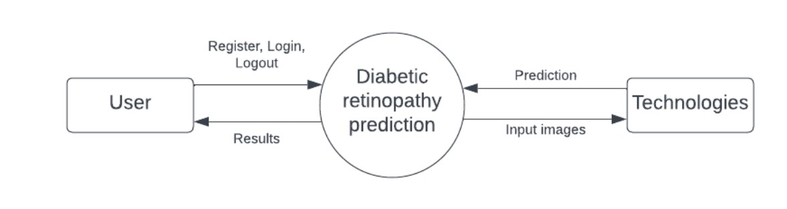

Figure 1. Level 0 DFD for Diabetic retinopathy prediction.

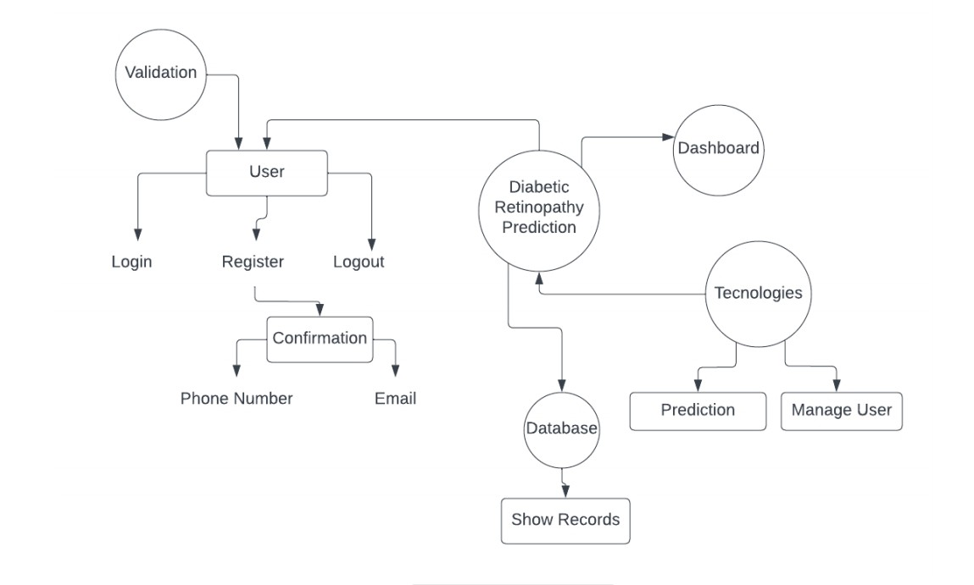

Figure 2. Level 1 DFD for Diabetic retinopathy prediction.

**User Stories:**

Use the below template to list all the user stories for the product.

|  |  |  |  |  |  |  |
| --- | --- | --- | --- | --- | --- | --- |
| **User type** | **Fundamental Requirement**  **(Epic)** | **User Story**  **Number** | **User Story / Task** | **Acceptance Criteria** | **Priority** | **Release** |
| Customer  (web user) | Registration | USN-1 | As a user, I can register for the application by entering my email, password, and confirming my password. | I can access my account / dashboard | High | Sprint-1 |
|  |  | USN-2 | As a user, I will receive confirmation email once I have registered for the application. | I can receive confirmation email. | High | Sprit-1 |
|  |  | USN-3 | The registration is confirmed using phone number. | I received a confirmation message. | Low | Sprint-2 |
|  |  | USN-4 | As a user, I can register for the application by entering email & password. | I can register via gmail. | Medium | Sprint-3 |
|  | Login | USN-5 | As a user, I can log into the application by entering & password. | I can log in to the application after registration. | High | Sprint-1 |
|  | Dashboard | USN-6 | User can see their dashboard | Users see their profile activity. | Medium | Sprint-4 |
|  | Validation | USN-7 | Validates user login id. | Checks for the mail. | Low | Sprint-2 |
|  | Patient’s name & ID | USN-8 | Doctor uses this report for seeing patient’s activity. | Storing patient’s ID. | Medium | Sprint-3 |
|  | Upload images | USN-9 | Prediction part. | Show the disease level. | High | Sprint-2 |
|  | Logout | USN-10 | Logout from the current. | Logs out | High | Sprint-4 |